**/*part B -5. Program to create an applet and draw grid line*/** //Save the file name with Grid.java

import java.awt.*;

import java.applet.*;

/*html code*/

/*<applet code="Grid.class" width="400" height ="300"></applet>*/

public class **Grid** extends Applet

{

public void paint (Graphics g)

{

int row,column,x,y=20;

//for every row

for(row=1;row<5;row++)

{

x=20;

//for every column.

for(column=1;column<5;column++)

{

g.drawRect(x,y,40,40);//drawRect(int x, int y, //int width, int height) ;/this will draw a //rectangle of width 50 & height 100 at (x,y)

x=x+20;

}

y=y+20;

}

}

}

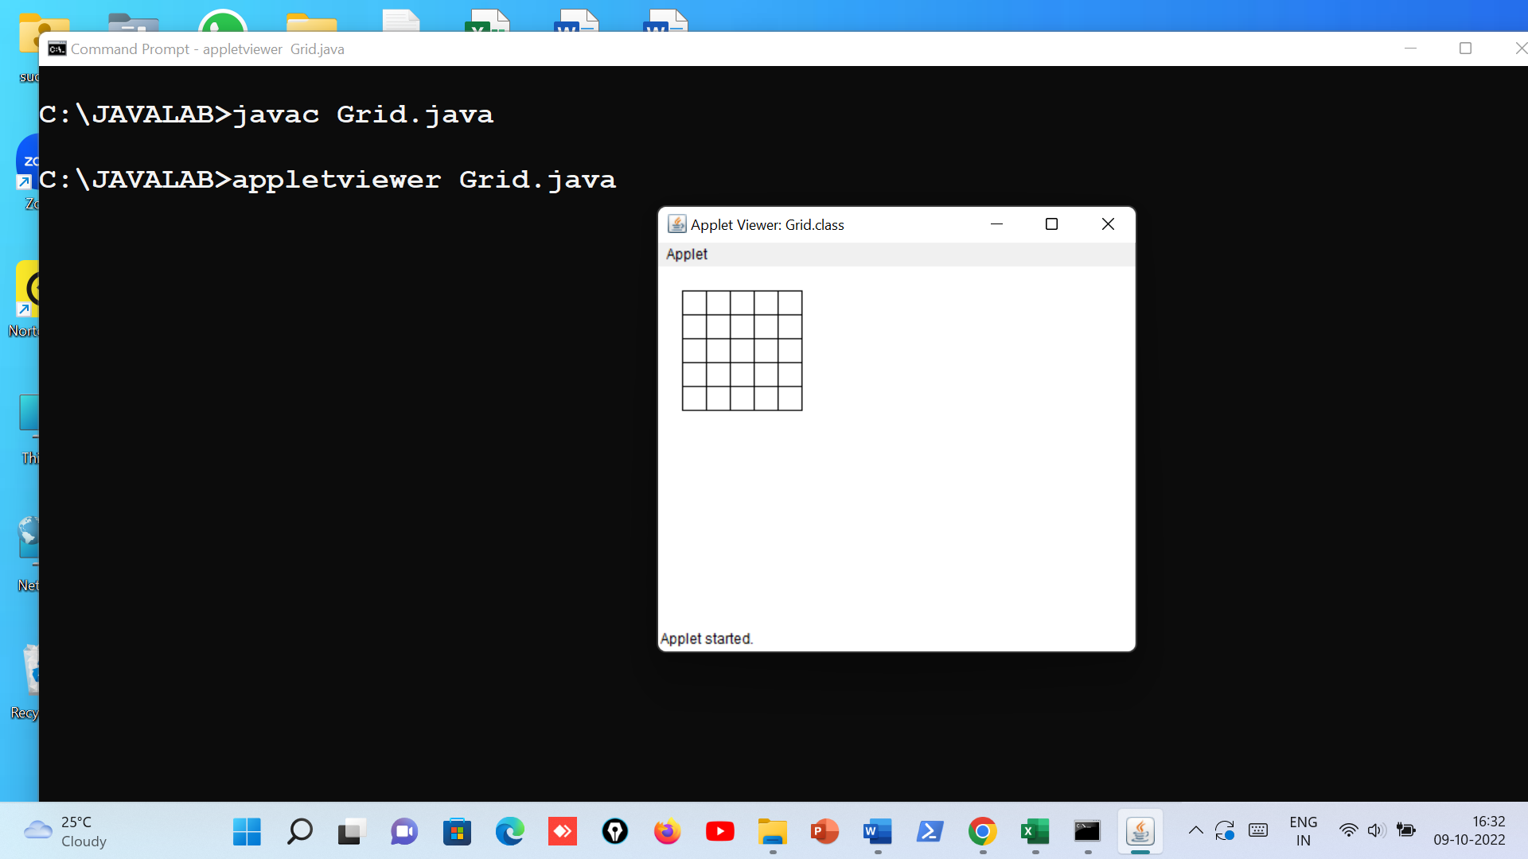

**/*part b 8.create a simple applet which reveals the personal information of Yours Filename Personalinfo.java*/**

/*

<applet code="Personalinfo.class" height="300" width="500">

</applet>

*/

import java.awt.*;

import java.applet.*;

public class Personalinfo extends Applet

{

Font f;

public void init()

{

setSize(500,500);

f=new Font ("Arial",Font.BOLD,20);

}

public void paint(Graphics g)

{

g.drawString("=============",50,50);

g.drawString("Personal Information",50,80);

g.drawString("=============",50,110);

g.drawString("Name:Charles",50,140);

g.drawString("Father Name:James",50,170);

g.drawString("Date of Birth:02/03/1995",50,200);

g.drawString("Address No:50,MG Road,Kolar",50,230);

g.drawString("Mobile Number:9123456789",50,260);

g.drawString("E-mail:charles1995@gmail.com",50,290);

}

}

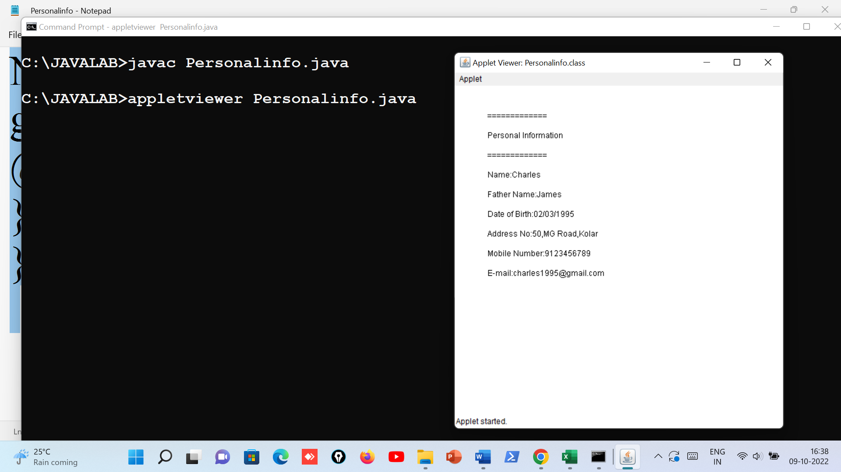

**/* Mouse handling events- File name MouseEvents1.java*/**

import java.applet.*;

import java.awt.*;

import java.awt.event.*;

**/*<applet code="MouseEvents1.class" width=300 height=100></applet>*/**

public class MouseEvents1 extends Applet implements MouseListener

{

String msg = "Initial Message";

public void init(){

addMouseListener(this);

}

public void mouseClicked(MouseEvent m){

msg = "Mouse Clicked";

repaint();

}

public void mousePressed(MouseEvent m){

msg = "Mouse Pressed";

repaint();

}

public void mouseReleased(MouseEvent m){

msg = "Mouse Released";

repaint();

}

public void mouseEntered(MouseEvent m){

msg = "Mouse Entered";

repaint();

}

public void mouseExited(MouseEvent m){

msg = "Mouse Exited";

repaint();

}

public void paint(Graphics g){

g.drawString(msg, 30, 30);

}

}

